
The Rabbit

Macmilliant Effort

Finzean Primary School joined in the “World’s Biggest Coffee Morning” on September 25th to raise money for Macmillan Cancer Support. On a hugely successful day, they held a come to school dressed in green day and had stalls with competitions, raffles, merchandise and home baking. A fantastic sum of £1,035 was raised and the school would like to thank all the parents, families and friends and members of the community who helped make the day so successful.
Two of the pupils, Robin Falvey P6 and Findlay Shand P4 were interviewed on Original 106 radio station to publicise the event.
The pupils spent part of the following week writing reports on what had gone on.
Rory Hector wrote that all the children dressed up in green and that all the teachers wore green wigs which made them look very funny. He also said that they had invited the Director of Education and Her Majesty the Queen.
Amy Christie wrote about how exciting the day had been and about how much fun people had had trying the various competitions. She also went on to say how nice the hall looked after it was decorated and what a success the day was.
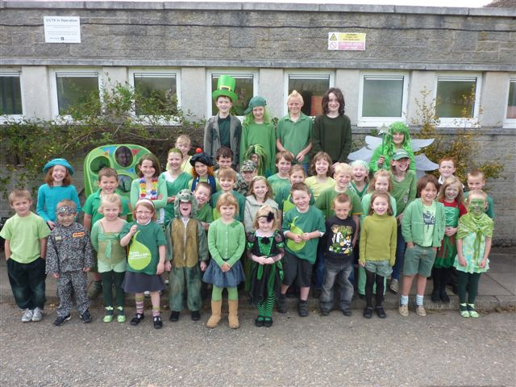

October 09

OCTOBER 08

Bonfire Night

This year the now annual Bonfire Display takes place on (surprise, surprise!) the 5th of November. The bonfire will be lit at 6pm with the fireworks taking to the skies at 6.30pm.
Soup, Donna’s Stovies and hot dogs will be available for supper and glow sticks and
sparklers will be on sale to entertain the kids.
This years Fireworks will be kindly sponsored by local tradesmen Craig Thow, Electrical Contractor and Davie Hector, Joiner, Finzean Dancing Group and by Finzean Community Association. Once again Finzean Community Association are indebted to Criag, Davie and the Dancing Class for their ongoing support.
The first firework that will be let off is in memory of Jonathan Gordon and was kindly donated by Angus & Judy Gordon
It is also hoped to have a ‘Hamper Raffle’ on the night to help raise funds.
Anyone who would like to contribute anything for the Hamper should drop it off at Hazel Strachan, Bloomfield (850717) or Wendy Hector, Taigh En Heir (850453) by Tuesday 3rd November.
Anyone who would like to help on the night should contact Wendy (850453).
Anyone who would like to help build the bonfire should meet at the Hall Car Park on
Saturday 31st at 9.30 a.m.
Anyone who may have suitable materials for the bonfire should contact Kevin (850717)

Under 5’s

Finzean Under Fives meet on a Thursday morning between 10-12pm £1.50 per session. All welcome.

Dates for your diary; Halloween Party 29th Oct Fancy dress please
Soft Bear Centre 3rd Dec
Christmas Party 17th Dec with a visit from Santa
Mum Night Out 18th Dec at Banchory Scott Hut "Bring A Party 2 a Party" See Julie Christie for more info if you fancy coming ........ Anyone Welcome.

Finzean Under Fives Christmas Card Deliverers.
10 Pence per card. Deliverers will take place on the 12th-13th & 19th & 20th. All Christmas card to be in by the Thursday of that weekend. Cards can be handed in at Under fives on the Thursday morning or dropped off at Maree’s house or special arrangements can be made.

Finzean Under Fives wish everyone A Very Merry Christmas and Happy New Year.
For any information call Maree (Tel: 850274)

Finzean Branch of the Scottish Women's Rural Institute, meets on the third Thursday of each month Sept to April at 7.30pm in Finzean Hall, new members always welcome.
Our Syllabus for 2009-2010
September we looked at Family Trees and Betty Taylor from North East Family History Society gave members tips on looking for relatives.
October 15th This is our charity table meeting, Lynda Taberner from K & D Befriending will give a talk and we will have a sales table with the proceeds going to charity.
Competitions: Friendship bracelet and 2 slices of a tray bake.
November 19th This is our Birthday party, last year we had a Pot Luck Supper and games, very much enjoyed by all members.
December 3rd Cookery demonstration by Michelle Patterson.
Competitions: Computer generated greetings card and 3 pieces of shortbread.
December 5th This is our childrens Christmas party.
January 21st Card making techniques by Moyra Gray.
Competitions: 5"x7" snapshot of an animal and 2 slices of meat loaf.
February18th Complementary therapy by Jacquie Christie
Competitions: Painted stone and wedge of cheesecake.
March 18th Flower arranging by Jill Hay of Hay's Flowers.
Competitions: Flower arrangement in a wine glass and coconut ice.
April 15th This will be our business meeting
Competitions: Favorite holiday keepsake and 2 rock cakes

Farmers Ball

The Farmers Ball takes place again this year on Saturday 12th December
at Finzean Hall so we look forward to seeing you for another fun evening.
Tickets will go on sale early November so make sure you book early to
avoid disappointment!

Finzean Hall Bookings 2009/10

The Finzean hall Bookings Diary will be held by the people listed below on the following months. In order to make a booking, please contact the appropriate person.
Month Name Tel. No.
September & October Kevin & Hazel Strachan 850717
November & December Alan & Jane Bennett 850748
January & February Colin & June Whyte 850327
March & April Davie & Wendy Hector 850453
May & June Craig & Donna Thow 850421
July & August Hector & Eydie Riddell 850220

Finzean Graveyard

The Graveyard was officially ‘opened’ (not sure what the correct term is!) on 30th May this year, when it was handed over to Aberdeenshire Council who now manage the graveyard. This was the conclusion of a huge community effort which included:
Putting in over 400 metres of track to the graveyard
Planting over 350 metres of hedges and over 180 trees and whips
Sowing over 500 sq metres of new grass
Installing over 400 metres of stock/rabbit fencing, 140 posts and 10 gates
This was a real community project and is something that we should be very proud of – certainly no one has done anything like it in Aberdeenshire. We would like to thank all the people who gave up their time to support the project - without this support the whole project would never have happened.
We still have a small amount of money left over in the graveyard account and we intend to keep this for any additional work we need to do over the next 2-3 years to improve the graveyard. We are planning to have one more “Community Planting Day” next spring to plant out wild flowers and also to replace the small number of trees that have not taken.
Finally just to say that there have been there have been 2 burials in the Graveyard since the opening.

Finzean Dancing Class

With the dark nights upon us again, the dancing class has started to meet up again on a Tuesday night. With only 6 weeks until the dance there’s a lot of brushing up required. As in previous years the dancing club continues to be a non- profit-making club, with what we take in going back out to local charities and good causes. Since the last edition of the rabbit we have gifted money to The Finzean Friendship Club, The community Bonfire and The Archie foundation based in Aboyne. The Annual BBQ was well attended with everyone enjoying a sociable evening of good food, music and company. The proceeds of the October dance are going to be gifted to the cancer charity CLIC sergeant. We are again going to be one of the sponsors of the bonfire night and in the New Year we are to support Finzean Schools Race Night.

Church Exercise Class

Finzean Church Exercise class has been running for over a year and takes place at Finzean Church on Monday nights between 7-8pm. Exercise DVD’s are played on the big screen, exercise dvd will vary every 4-6 weeks.
£2.00 per class, all money goes to buying new dvds or buying anything the church requires. Come along and give it a try!
For more info contact Maree 850274

FINZEAN HALL…………

Badminton continue to meet on a Monday Evening from 7.30pm until 10pm –
all welcome – contact June White (850327).

Senior Citizens Christmas Show

Finzean Community Association and Finzean Primary School will combine in December to put on a Christmas show for the more senior members of our community on December 8th.
Invites will be sent out accordingly, but its sometimes difficult to determine those of you that are actually over 60years old, so please don’t be shy and inform Donna on 850421 if you are indeed eligible for an afternoons entertainment and tea and cakes.

FINZEAN ESTATE FARM SHOP & TEAROOM
The shop and tearoom are now
OPEN SEVEN DAYS
Mon – Sat
9am – 5pm
Sunday
12.00 – 5pm
f

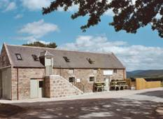

This year the Finzean Farm Shop hope to have a Christmas Fayre at the end of November.
The dates are still to be finalised but more information will be available from the Farm shop nearer the time.

Chief Executive visits Finzean

New Chief Executive of Aberdeenshire Council, Colin Mackenzie recently visited Finzean to sample the community spirit for himself.
He met with members of the community and received presentations from Guy about the Graveyard and the Hall, John about the Community and Mel about POOT.
Following lunch at the Farm Shop, he then received a tour of the area by Angus Faquharson.

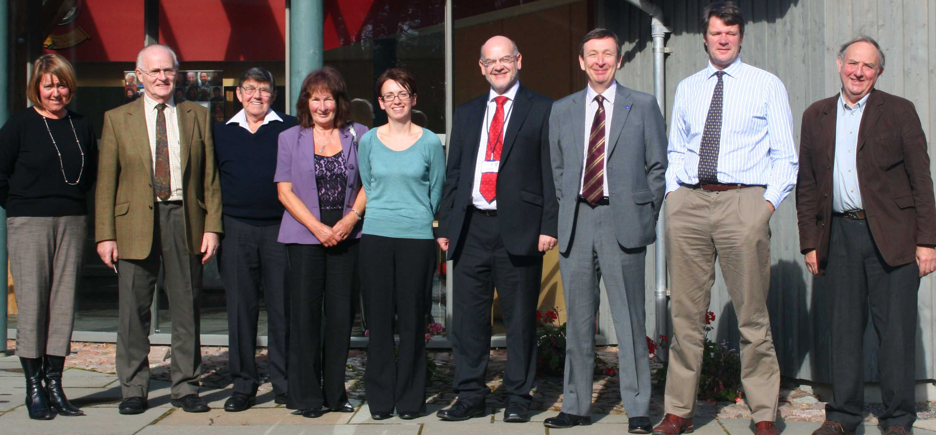

www.portrait-of-our-time.co.uk
For POOT and plenty of other things, why not visit the website for lots of up to date information about what’s going on in the local areas

Finzean School and Ballogie Nursery
Parent Forum NEWS!

The school is settling down again now under the excellent leadership of our new head – Mrs Julie Hughson who is a great supporter of school and community partnerships, if you have not already met her then there will be an opportunity to do so very soon!

DIARY DATES!
We will hold our annual Christmas Fair on November 28th at Finzean Hall 1-4pm. Stalls will include Christmas crafts, home produce, toys, books and much more. Come along for your afternoon tea and you just might see Santa too!
All donations to the home baking/produce stall and raffle would be very much appreciated.

On February 20th we are holding a fund raising horse race night at Banchory Scout Hut. Please contact Moira Aitken 01330 850515 for tickets or to sponsor a race.
A huge thank you to everyone who supported our recent fundraising events, we had over one ton of rag bags which earned the school £308.10 and our Macmillan coffee morning raised an amazing £1035 in 90 minutes for the very worthy Macmillan charity, our best total yet
To help with fundraising, the PTA holds six whist evenings and a family bingo night over the winter nights. These nights are an extremely successful way of keeping liaisons with the community active and are thoroughly enjoyed and appreciated by all attendees, many of who are senior members of our community.

The dates for this year are as follows:
Whist Dates Bingo Dates
30th October 2009 19 March 2010
20th November 2009
15th January 2010
26^{h} February 2010
26^{h} March 2010
23rd April 2010
All are at Finzean Primary School starting at 7pm.

PORTRAIT OF OUR TIME

“The Portrait of our Time exhibition brought 900 visitors through the door of the Birse and Feughside Church! This far exceeded our expectations with many people coming back for a second or a third visit. The feedback was amazing with Mel describing it as “a sort of community group hug!” We are currently processing the mountain of orders for prints and photographs, so please be patient and we will be in touch soon.
You can still buy copies of your photograph, a map or the book, direct from Mel on 850674 or at The Finzean Farm Shop.
The competitions were judged by the whole community and much admired by all visitors. The overall winner in the adult photography category went Lynn Allen for her amazingly atmospheric winter view with chilly sheep, 2nd prize with another winter shot of Clach na Ben goes to Gary Grant. The adult poetry section, was won by Doreen Christie with “Where I live” and 2nd went to Pat Lawson with “The Burns Supper.”
Poetry must run in the Christie Clan with 10yr old Kieran Strachan winning the children’s category with sisters Evie (age 6) and Robyn Falvey (10) taking 2nd & 3rd respectively.
The children’s competitions were keenly contested with 9yr old Amy Christie winning 1st in the photography section with her lovely rainbow picture, 2nd went to Gemma Christie with her picture of flowers surrounding the Finzean sign.
The committee are now turning their minds to the Community Play which is planned for January 2010. The play will tell some of the stories gathered from the interviews
We shall soon contact those of you who have already volunteered but are still looking for budding actors, singers, back stage people to help out. If you would like to put you name down then please contact Mel (actors) on 850674, Louise Counsell (Musicians) on 850323 or Guy Haslam (backstage) on haslam.finzean@virgin.net.
There will be something for everyone our aim is to have a real community play with as many people involved as possible and therefore we are looking for as many people to volunteer as possible.
Pictured left are some of the competition winners.

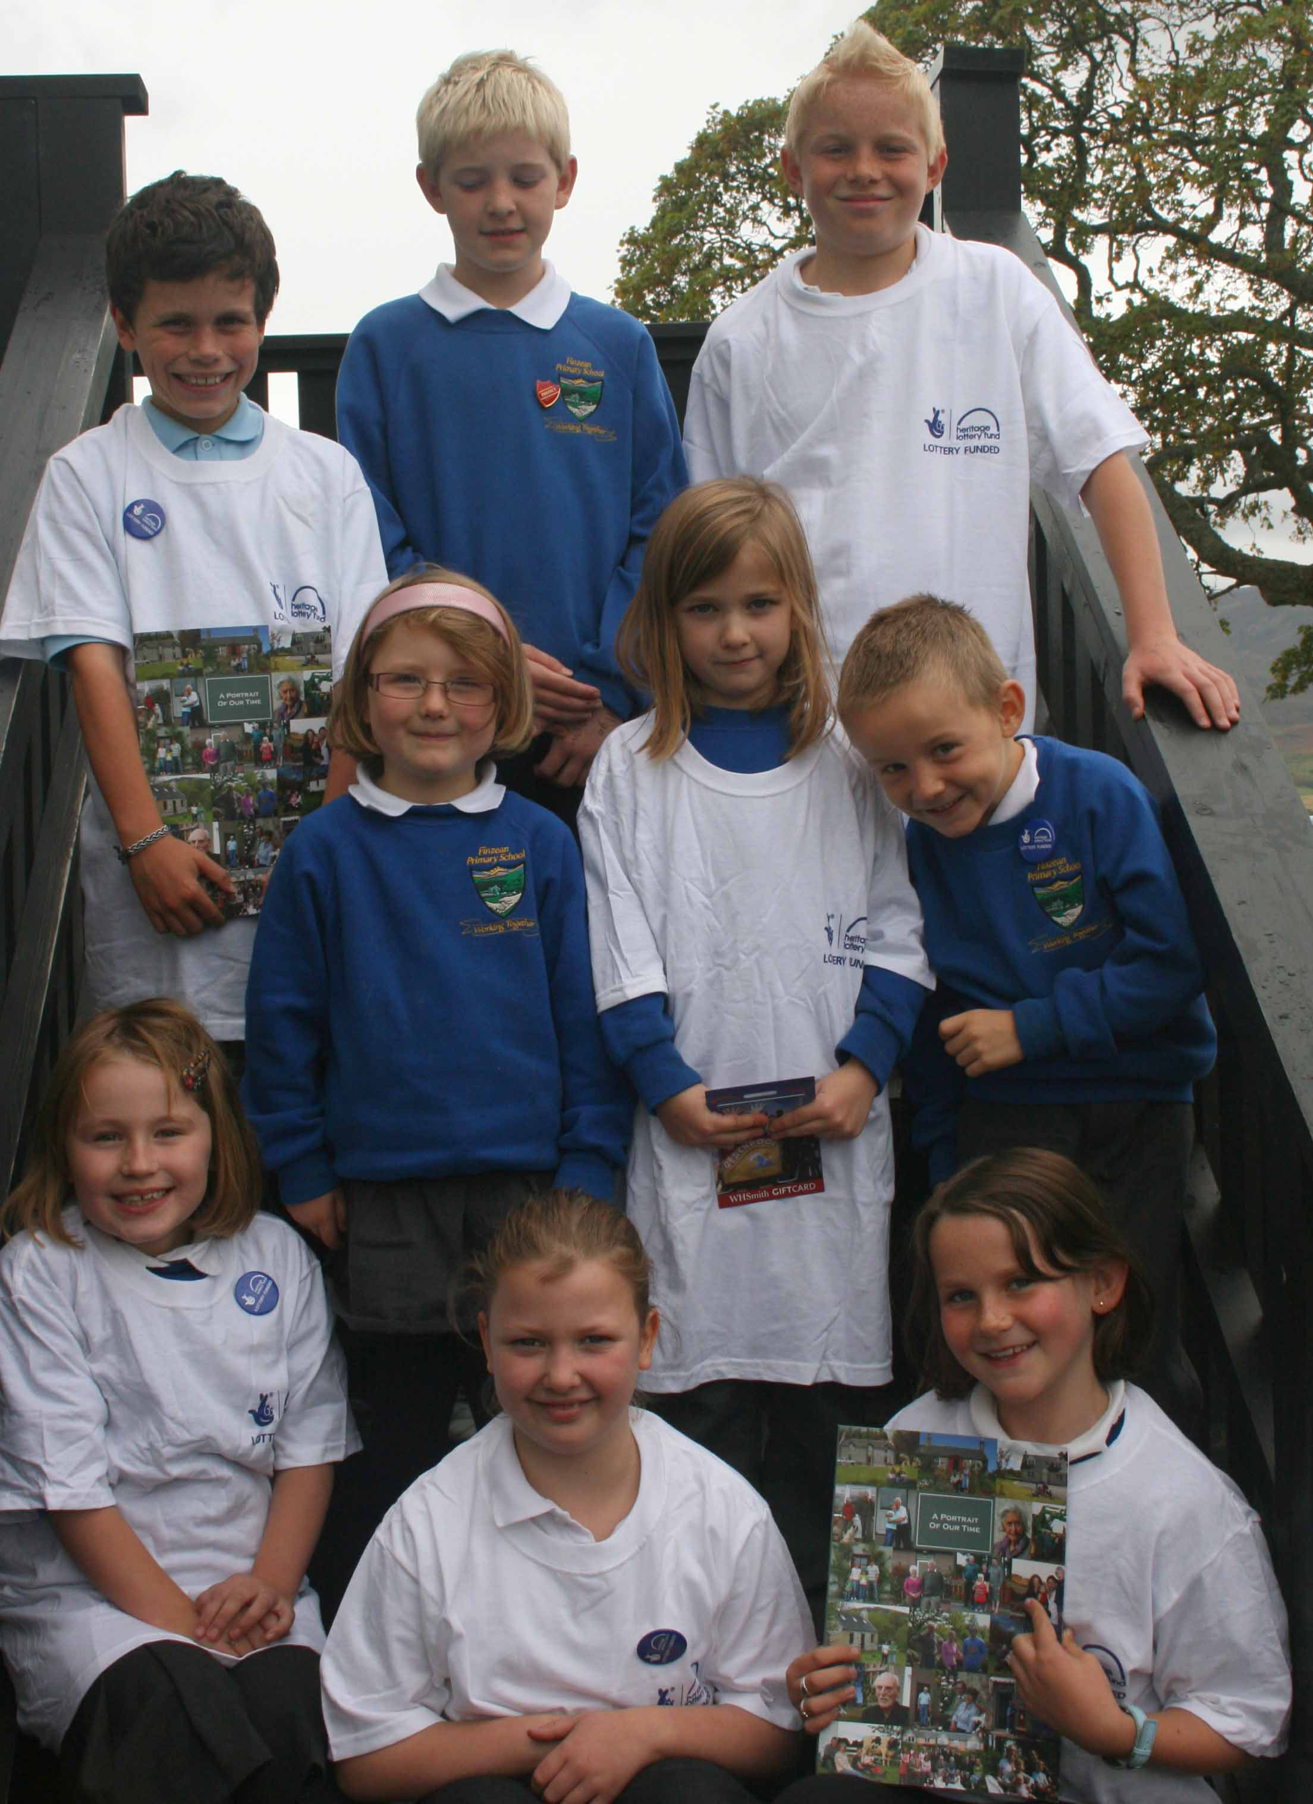

BIRSE AND FEUGHSIDE PARISH CHURCH

A Busy Summer
The summer is normally a quiet time for the church, but not this year. In July the Open Garden day at Finzean House raised £1600 for the Forget-Me-Not Club.
In August we welcomed over 230 people to the special Homecoming service in the Church and four Summer Promenade Concerts took place and raised £340 for the Forget-Me-Not Club.
Then as September began, we hosted the 10th birthday party for the Forget-Me-Not Club at Finzean House, the Portrait of our Time Exhibition saw over 900 people come through our doors over the week, we were the venue for the farewell presentation to the local postie, and the representatives of our Twinning partners from the Icaciri Church of Kenya, the Rev Joseph Njoroge and Mr Daniel Gaturu arrived for a two week visit, and an eco-fun craft morning for children took place.

Global Twinning
Last December the congregation signed a letter that invited the Icaciri Church in Kenya to become our twinning partners. Icaciri is a rural region to the north of Nairobi. Having been awarded a grant by the World Mission Council of the Church of Scotland we were able to invite two representatives from Kenya to visit the parish for two weeks. The Rev Joseph Njoroge and Mr Daniel Gaturu arrived on Saturday evening, 19 September. They were guests at the manse and over the two weeks visited the parish including the schools and nursery, the sawmill, Finzean farm and the shop. They also went further afield to Banchory, Ballater, Stonehaven and even to Edinburgh where they had lunch at the Scottish Parliament and watch First Minister’s Questions from the gallery.
They took part in the church service on Sunday 4 October and were presented with a framed copy of Mel Shand’s watercolour map of the parish. Mel was on hand to take a photograph of the two men with the congregation which shall be sent to Kenya in due course. If anyone in Finzean would like to know more about the twinning or how to take part in it, please contact Pauline Rumbles (013398 86841).

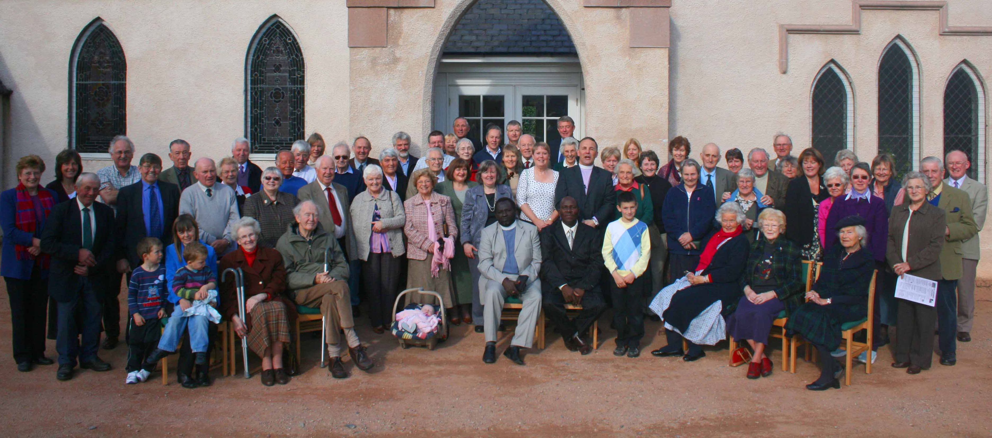

Special Services
The following services may appeal to people in Finzean with the assurance that you will be warmly welcomed should you decide to attend.
Sunday 26 October 11am: Harvest Thanksgiving. We invite the congregation to bring a gift for the harvest table that will be distributed later to the elderly, hospitals and nursing homes. Our service focuses on the work of charities working for fairness and development in Third World countries.

Sunday 8 November 10.45am: Remembrance Day. With the nation we will remember the war dead with two minutes silence at 11am. We also honour the local war dead with a wreath laid at the memorial attached to the wall of the church at the conclusion of the service.

Sunday 29 November. 11am Advent Sunday and a Eco-Family Service. To mark the season of Advent the congregation will light the candles on the Advent Wreath. Our eco-group, that seeks to encourage us in responsibility for the environment and better stewardship of resources, will lead the service along with the Rev Ann Cameron, Auxiliary Minister. The content will be suited to all ages.

Sunday 20 December 11am Christmas Family Service. The minister is delighted that once again the teachers and pupils of Finzean School will participate in the service presenting a musical Nativity play.

Christmas Eve 6.30pm Family Christingle Service. This is a popular service that attracts people from beyond the parish. Children are asked to bring a Christingle and adults candles to create the magical moment when the lights are dimmed and by candlelight we sing Christmas carols that announce the birth of Jesus.
Christmas Day 10am Christmas Family Worship. A short, informal service to which everyone is encouraged to bring a gift they have received to show to the minister.

Social Occasions
In addition to acts of worship the church also arranges social evenings and invites the wider community to share in them.
6 November 7.30pm Gershwin Remembered. A supper evening that will include Jack Holt giving a concert of tunes by George Gershwin played on the clarinet. This will be illustrated visually by Gershwin’s life story.
For further information about tickets please contact Sheena Littlejohn (01330 850329).

11 December 7.30pm Christmas Music and Movies. This annual concert features songs and music for the festive season along with clips from Christmas films and cartoons old and new. The evening ends with mince pies.

